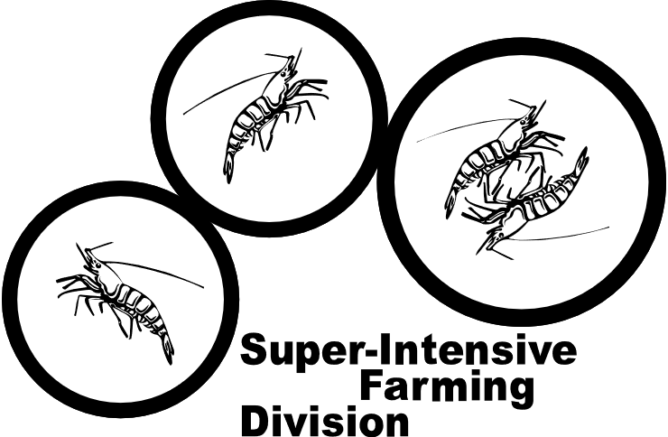**Glory Aquaculture Ptv. Ltd (Proposed)**

Super-Intensive Farming Division (SFD)

**Weather Station Sensors Cheat Sheet**

The codes are licensed under GNU LESSER GENERAL PUBLIC LICENSE

* Everyone is permitted to copy and distribute verbatim copies of this license document, but changing is not allowed.

Exclusive rights to Rouf Aquaculture Bangladesh Pvt. Ltd (Proposed), Khulna, Bangladesh

Documented by: Asmaul Rahat, CEE

* **Wind Speed Sensor Slave ID : 01**

**Steady Position**

-> 01 03 00 00 00 02 C4 0B

-< 01 03 04 00 **00** 00 B5 3B 84 (Only 1 bit data return)

^

|

**Data**



* **Wind Direction Sensor Slave ID: 02**

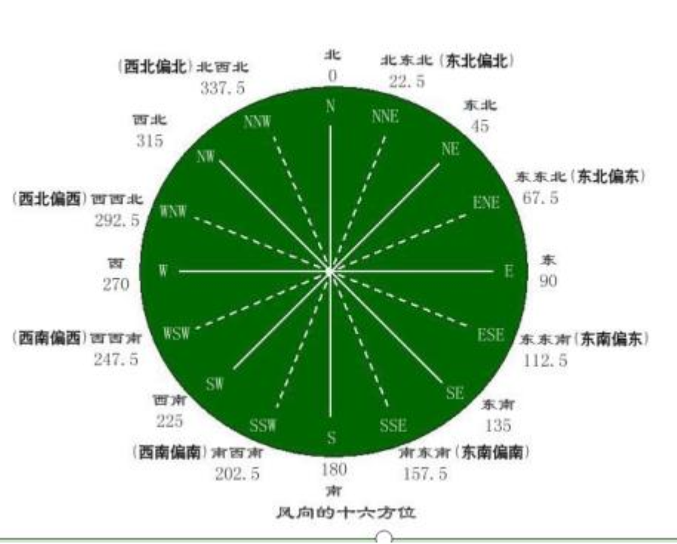

TX ->

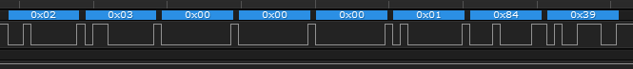

RX <-

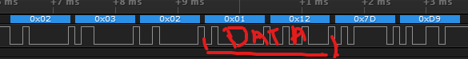

* **Temperature Humidity Sensor Slave ID: 03**

**Read Current Device Address:**

**TX ->**

0x01 0x03 0x01 0x00 0x00 0x01 0x85 0xF6

**RX<-**

0x01 0x03 0x02 0x00 **0x01** 0x79 0x84 (Bold is the device address)

**Modify Device Address from 01 to 03:**

**TX ->**

**0x01 0x06 0x01 0x00 0x00 0x03 0xC8 0x37**

**Read Humidity and Temp Data:**





**Rain Sensor Slave ID: 04**

